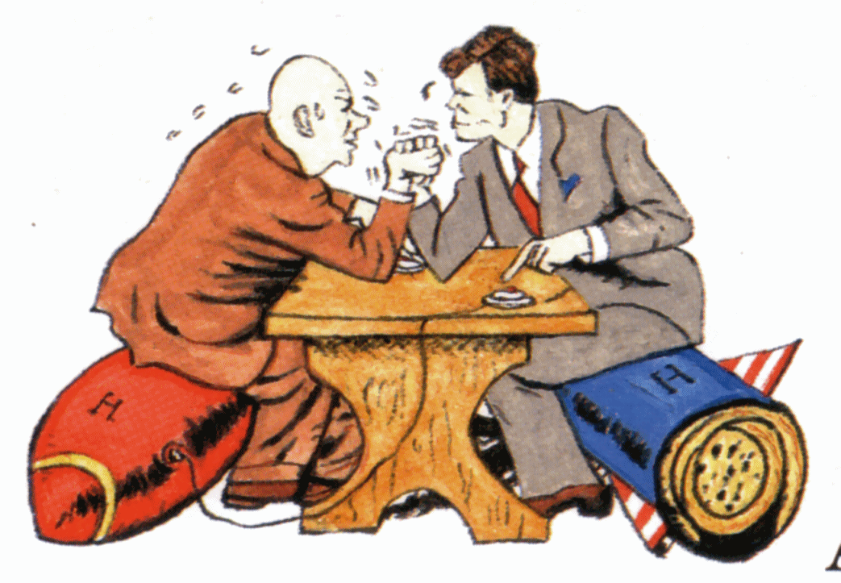
Cold War Project:

This project is to help you become well-versed with one event from the Cold War. You and your partner will become experts at the event you present on.

Please be creative on this project. Ideas can include: creating a news report video, PowerPoint presentation with audio, music video, etc. If you want to do something unique (something other than what’s listed) please get it cleared with your teacher before you begin working. You can use any academic source for information. If you are making a video for your presentation you must upload it to YouTube and send the link, not the video. This project can be submitted at any time but must be submitted by 11:59pm on the day your final exam is scheduled. If you have any questions or need further clarification on the project please reach out to your teacher well before the due date!

Possible topics to choose from: Berlin airlift, Cuban missile crisis, Korean War, Vietnam war, Berlin Wall, Space race, 1980 olympic hockey game, Creation of the nation of Israel

Project Rubric

______/5 points Submitted on time

______/5 points Followed submission directions

______/10 points Works cited

______/10 points Who was involved in the event

______/10 points Where did this event take place

______/10 points When did this event take place

______/10 points Describe what occurred

______/10 points Why did this happen and what was the outcome?

______/10 points Presentation is between 4-5 minutes in length

______/20 points Creativity and original thought are evident

______/100 points Total (goes in as 10% of your grade in final exam category)

